**Artificial Intelligence Lab**

**LAB 7 – Unification and Resolution**

**Aditya Kumar**

**RA1911030010100**

**O2 Section**

**Date – 15/3/22**

**Problem Statement :**

Implementation of unification

**Algorithm :**

1. Initialize the substitution set to be empty.
2. Recursively unify atomic sentences:

* Check for Identical expression match.
* If one expression is a variable vi, and the other is a term ti which does not contain variable vi, then:
* Substitute ti / vi in the existing substitutions
* Add ti /vi to the substitution setlist.
* If both the expressions are functions, then function name must be similar, and the number of arguments must be the same in both the expression.

For each pair of the following atomic sentences find the most general unifier (If exist).

**Code:**

def get_index_comma(string):

index_list = list()

par_count = 0

for i in range(len(string)):

if string[i] == ',' and par_count == 0:

index_list.append(i)

elif string[i] == '(':

par_count += 1

elif string[i] == ')':

par_count -= 1

return index_list

def is_variable(expr):

for i in expr:

if i == '(' or i == ')':

return False

return True

def process_expression(expr):

expr = expr.replace(' ', '')

index = None

for i in range(len(expr)):

if expr[i] == '(':

index = i

break

predicate_symbol = expr[:index]

expr = expr.replace(predicate_symbol, '')

expr = expr[1:len(expr) - 1]

arg_list = list()

indices = get_index_comma(expr)

if len(indices) == 0:

arg_list.append(expr)

else:

arg_list.append(expr[:indices[0]])

for i, j in zip(indices, indices[1:]):

arg_list.append(expr[i + 1:j])

arg_list.append(expr[indices[len(indices) - 1] + 1:])

return predicate_symbol, arg_list

def get_arg_list(expr):

_, arg_list = process_expression(expr)

flag = True

while flag:

flag = False

for i in arg_list:

if not is_variable(i):

flag = True

_, tmp = process_expression(i)

for j in tmp:

if j not in arg_list:

arg_list.append(j)

arg_list.remove(i)

return arg_list

def check_occurs(var, expr):

arg_list = get_arg_list(expr)

if var in arg_list:

return True

return False

def unify(expr1, expr2):

if is_variable(expr1) and is_variable(expr2):

if expr1 == expr2:

return 'Null'

else:

return False

elif is_variable(expr1) and not is_variable(expr2):

if check_occurs(expr1, expr2):

return False

else:

tmp = str(expr2) + '/' + str(expr1)

return tmp

elif not is_variable(expr1) and is_variable(expr2):

if check_occurs(expr2, expr1):

return False

else:

tmp = str(expr1) + '/' + str(expr2)

return tmp

else:

predicate_symbol_1, arg_list_1 = process_expression(expr1)

predicate_symbol_2, arg_list_2 = process_expression(expr2)

# Step 2

if predicate_symbol_1 != predicate_symbol_2:

return False

# Step 3

elif len(arg_list_1) != len(arg_list_2):

return False

else:

# Step 4: Create substitution list

sub_list = list()

# Step 5:

for i in range(len(arg_list_1)):

tmp = unify(arg_list_1[i], arg_list_2[i])

if not tmp:

return False

elif tmp == 'Null':

pass

else:

if type(tmp) == list:

for j in tmp:

sub_list.append(j)

else:

sub_list.append(tmp)

# Step 6

return sub_list

if __name__ == '__main__':

f1 = 'Q(a, g(x, a), f(y))'

f2 = 'Q(a, g(f(b), a), x)'

# f1 = input('f1 : ')

# f2 = input('f2 : ')

result = unify(f1, f2)

if not result:

print('The process of Unification failed!')

else:

print('The process of Unification successful!')

print(result)

**Output:**

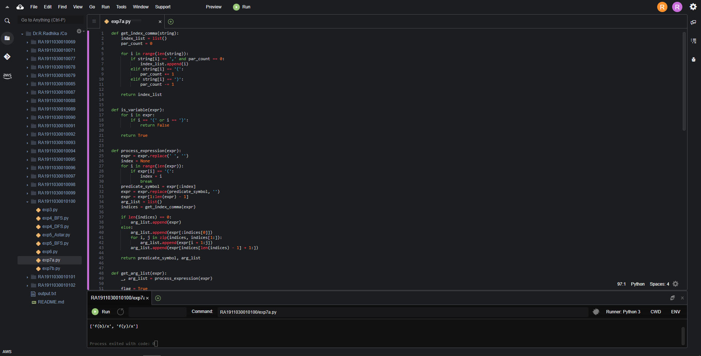

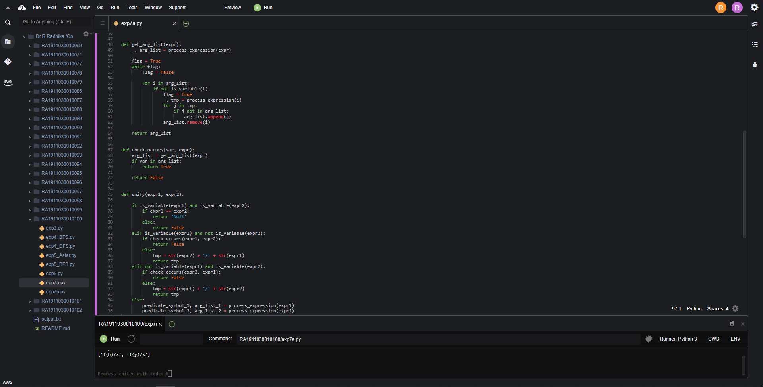

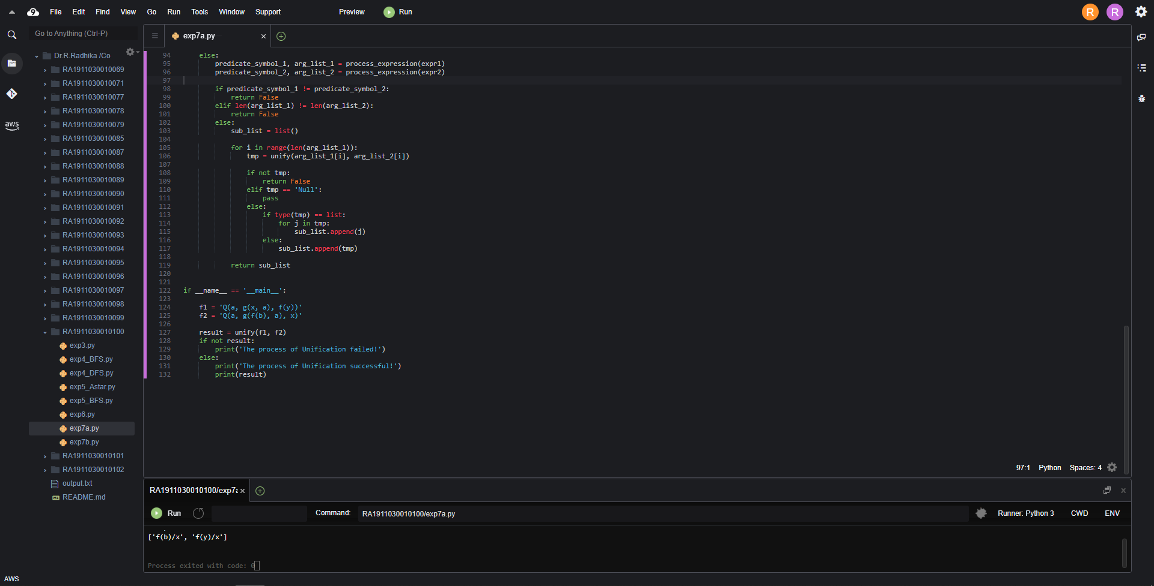

**Result:**

Hence we performed unification.